**Lab: File path traversal, validation of file extension with null byte bypass**

Problem: The application validates that the supplied filename ends with the expected file extension

Goal: To solve the lab, retrieve the contents of the /etc/passwd file.

Solve:

1-

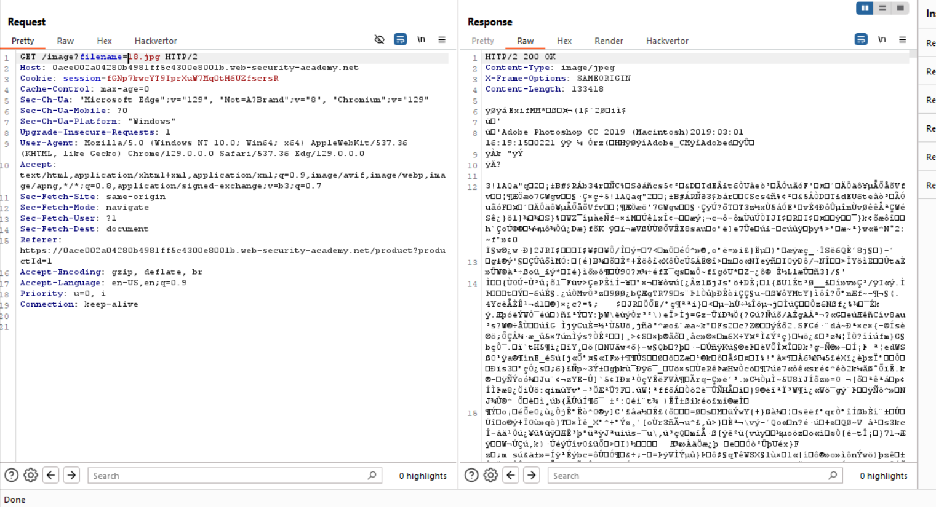

2-

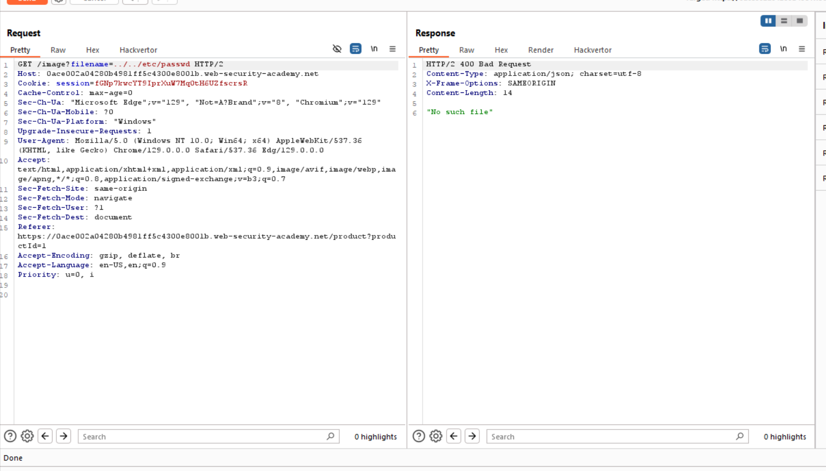

3-



